Statistika
Statistics
 |  | survival | usia | jenis_kelamin | metode_jatuh | klasifikasi_cidera
N | Valid | 212 | 212 | 212 | 212 | 212
N | Missing | 0 | 0 | 0 | 0 | 0

survival
 |  | Frequency | Percent | Valid Percent | Cumulative Percent
Valid | meninggal | 7 | 3.3 | 3.3 | 3.3
Valid | survival | 205 | 96.7 | 96.7 | 100.0
Valid | Total | 212 | 100.0 | 100.0

usia
 |  | Frequency | Percent | Valid Percent | Cumulative Percent
Valid | 0-11 | 14 | 6.6 | 6.6 | 6.6
Valid | 12-18 | 27 | 12.7 | 12.7 | 19.3
Valid | 19-35 | 67 | 31.6 | 31.6 | 50.9
Valid | 36-45 | 20 | 9.4 | 9.4 | 60.4
Valid | 46-60 | 47 | 22.2 | 22.2 | 82.5
Valid | >60 | 37 | 17.5 | 17.5 | 100.0
Valid | Total | 212 | 100.0 | 100.0

jenis_kelamin
 |  | Frequency |  | Percent |  | Valid Percent |  | Cumulative Percent
Valid | laki-laki | 139 |  | 65.6 |  | 65.6 |  | 65.6
Valid | perempuan | 73 |  | 34.4 |  | 34.4 |  | 100.0
Valid | Total | 212 |  | 100.0 |  | 100.0
metode_jatuh
 |  |  | Frequency |  | Percent |  | Valid Percent |  | Cumulative Percent
Valid | KLL |  | 169 |  | 79.7 |  | 79.7 |  | 79.7
Valid | jatuh dari ketinggian |  | 43 |  | 20.3 |  | 20.3 |  | 100.0
Valid | Total |  | 212 |  | 100.0 |  | 100.0

klasifikasi_cidera
 |  | Frequency | Percent | Valid Percent | Cumulative Percent
Valid | minor | 155 | 73.1 | 73.1 | 73.1
Valid | moderate | 25 | 11.8 | 11.8 | 84.9
Valid | severe | 32 | 15.1 | 15.1 | 100.0
Valid | Total | 212 | 100.0 | 100.0

Analisa Bivariat
jenis_kelamin * survival Crosstabulation
Count
 |  | survival |  | Total
 |  | meninggal | survival | Total
jenis_kelamin | laki-laki | 7 | 132 | 139
jenis_kelamin | perempuan | 0 | 73 | 73
Total |  | 7 | 205 | 212

Chi-Square Tests
 | Value | df | Asymptotic Significance (2-sided) | Exact Sig. (2-sided) | Exact Sig. (1-sided)
Pearson Chi-Square | 3.963ª | 1 | .047
Continuity Correction^{b} | 2.524 | 1 | .112
Likelihood Ratio | 6.243 | 1 | .012
Fisher's Exact Test |  |  |  | .053 | .045
Linear-by-Linear Association | 3.944 | 1 | .047
N of Valid Cases | 212
a. 2 cells (50.0%) have expected count less than 5. The minimum expected count is 2.48.
b. Computed only for a 2x2 table

usia * survival Crosstabulation
Count
 |  | survival |  | Total
 |  | meninggal | survival | Total
usia | 0-11 | 0 | 14 | 14
usia | 12-18 | 1 | 26 | 27
usia | 19-35 | 4 | 63 | 67
usia | 36-45 | 2 | 18 | 20
usia | 46-60 | 0 | 47 | 47
usia | >60 | 0 | 37 | 37
Total |  | 7 | 205 | 212

Correlations
 |  |  | usia | survival
Kendall's tau_b | usia | Correlation Coefficient | 1.000 | .071
Kendall's tau_b | usia | Sig. (2-tailed) | . | .246
Kendall's tau_b | usia | N | 212 | 212
Kendall's tau_b | survival | Correlation Coefficient | .071 | 1.000
Kendall's tau_b | survival | Sig. (2-tailed) | .246 | .
Kendall's tau_b | survival | N | 212 | 212

mekanisme * survival Crosstabulation
Count
 |  |  |  |  |  | survival |  |  |  |  |  | Total
 |  |  |  |  |  | meninggal |  |  |  | survival
mekanisme |  | KLL |  |  |  | 7 |  |  |  | 162 |  | 169
 |  | JAtuh dari ketinggian |  |  |  | 0 |  |  |  | 43 |  | 43
Total |  |  |  |  |  | 7 |  |  |  | 205 |  | 212
Chi-Square Tests
 |  |  |  | Value |  |  | df |  | Asymptotic Significance (2-sided) |  |  |  | Exact Sig. (2-sided) |  |  | Exact Sig. (1-sided)
Pearson Chi-Square |  |  |  | 1.842ª |  |  | 1 |  | .175
Continuity Correction^{b} |  |  |  | .773 |  |  | 1 |  | .379
Likelihood Ratio |  |  |  | 3.234 |  |  | 1 |  | .072
Fisher's Exact Test |  |  |  |  |  |  |  |  |  |  |  |  | .349 |  |  | .199
Linear-by-Linear Association |  |  |  | 1.833 |  |  | 1 |  | .176
N of Valid Cases |  |  |  | 212
a. 1 cells (25.0%) have expected count less than 5. The minimum expected count is 1.42.
b. Computed only for a 2x2 table
jenis_cidera
 |  |  | Frequency |  | Percent |  |  | Valid Percent |  |  | Cumulative Percent
Valid | COR |  | 155 |  | 73.1 |  |  | 73.1 |  |  | 73.1
Valid | COS |  | 25 |  | 11.8 |  |  | 11.8 |  |  | 84.9
Valid | COB |  | 32 |  | 15.1 |  |  | 15.1 |  |  | 100.0
Valid | Total |  | 212 |  | 100.0 |  |  | 100.0

jenis_cidera * survival Crosstabulation
Count
 |  | survival |  | Total
 |  | meninggal | survival | Total
jenis_cidera | COR | 0 | 155 | 155
jenis_cidera | COS | 0 | 25 | 25
jenis_cidera | COB | 7 | 25 | 32
Total |  | 7 | 205 | 212

Correlations
 |  |  | jenis_cidera | survival
Kendall's tau_b | jenis_cidera | Correlation Coefficient | 1.000 | -.339**
Kendall's tau_b | jenis_cidera | Sig. (2-tailed) | . | .000
Kendall's tau_b | jenis_cidera | N | 212 | 212
Kendall's tau_b | survival | Correlation Coefficient | -.339** | 1.000
Kendall's tau_b | survival | Sig. (2-tailed) | .000 | .
Kendall's tau_b | survival | N | 212 | 212
**. Correlation is significant at the 0.01 level (2-tailed).

Correlations
 |  |  | GCS | survival
Spearman's rho | GCS | Correlation Coefficient | 1.000 | .363**
Spearman's rho | GCS | Sig. (2-tailed) | . | .000
Spearman's rho | GCS | N | 212 | 212
Spearman's rho | survival | Correlation Coefficient | .363** | 1.000
Spearman's rho | survival | Sig. (2-tailed) | .000 | .
Spearman's rho | survival | N | 212 | 212
**. Correlation is significant at the 0.01 level (2-tailed).

Correlations
 |  |  | TDS | survival
Spearman's rho | TDS | Correlation Coefficient | 1.000 | .528
Spearman's rho | TDS | Sig. (2-tailed) | . | .002
Spearman's rho | TDS | N | 212 | 212
Spearman's rho | survival | Correlation Coefficient | .028 | 1.000
Spearman's rho | survival | Sig. (2-tailed) | .682 | .
Spearman's rho | survival | N | 212 | 212

Correlations
 |  |  | RR | survival
Spearman's rho | RR | Correlation Coefficient | 1.000 | -.010
Spearman's rho | RR | Sig. (2-tailed) | . | .882
Spearman's rho | RR | N | 212 | 212
Spearman's rho | survival | Correlation Coefficient | -.010 | 1.000
Spearman's rho | survival | Sig. (2-tailed) | .882 | .
Spearman's rho | survival | N | 212 | 212

Descriptives
 |  |  | Statistic | Std. Error
TDS | Mean |  | 128.64 | 2.200
TDS | 95% Confidence Interval for Mean | Lower Bound | 124.30
TDS | 95% Confidence Interval for Mean | Upper Bound | 132.98
TDS | 5% Trimmed Mean |  | 127.58
TDS | Median |  | 121.50
TDS | Variance |  | 1026.136
TDS | Std. Deviation |  | 32.033
TDS | Minimum |  | 0
TDS | Maximum |  | 260
TDS | Range |  | 260
TDS | Interquartile Range |  | 36
TDS | Skewness |  | .323 | .167
TDS | Kurtosis |  | 3.292 | .333
GCS | Mean |  | 13.17 | .219
GCS | 95% Confidence Interval for Mean | Lower Bound | 12.74
GCS | 95% Confidence Interval for Mean | Upper Bound | 13.61
GCS | 5% Trimmed Mean |  | 13.56
GCS | Median |  | 15.00
GCS | Variance |  | 10.126
GCS | Std. Deviation |  | 3.182
GCS | Minimum |  | 3
GCS | Maximum |  | 15
GCS | Range |  | 12
GCS | Interquartile Range |  | 3
GCS | Skewness |  | -1.626 | .167
GCS | Kurtosis |  | 1.399 | .333
RR | Mean |  | 21.42 | .202
RR | 95% Confidence Interval for Mean | Lower Bound | 21.02
RR | 95% Confidence Interval for Mean | Upper Bound | 21.82
RR | 5% Trimmed Mean |  | 21.23
RR | Median |  | 20.00
RR | Variance |  | 8.633
RR | Std. Deviation |  | 2.938
RR | Minimum |  | 14
RR | Maximum |  | 32
RR | Range |  | 18
RR | Interquartile Range |  | 2
RR | Skewness |  | 1.313 | .167
RR | Kurtosis |  | 2.108 | .333

Tests of Normality
 | Kolmogorov-Smirnovª |  |  | Shapiro-Wilk
 | Statistic | df | Sig. | Statistic | df | Sig.
TDS | .106 | 212 | .000 | .932 | 212 | .000
a. Lilliefors Significance Correction

Tests of Normality
 | Kolmogorov-Smirnovª |  |  | Shapiro-Wilk
 | Statistic | df | Sig. | Statistic | df | Sig.
GCS | .382 | 212 | .000 | .635 | 212 | .000
a. Lilliefors Significance Correction

Tests of Normality
 | Kolmogorov-Smirnovª |  |  | Shapiro-Wilk
 | Statistic | df | Sig. | Statistic | df | Sig.
RR | .318 | 212 | .000 | .791 | 212 | .000
a. Lilliefors Significance Correction

Regresi

Case Processing Summary
Unweighted Casesª |  | N | Percent
Selected Cases | Included in Analysis | 212 | 100.0
Selected Cases | Missing Cases | 0 | .0
Selected Cases | Total | 212 | 100.0
Unselected Cases |  | 0 | .0
Total |  | 212 | 100.0
a. If weight is in effect, see classification table for the total number of cases.

Variables in the Equation
 |  | B | S.E. | Wald | df | Sig. | Exp(B)
Step 0 | Constant | 3.377 | .384 | 77.198 | 1 | .000 | 29.286

Variables not in the Equation
 |  |  | Score | df | Sig.
Step 0 | Variables | jenis_cidera | 33.139 | 1 | .000
Step 0 | Variables | TDS | .006 | 1 | .938
Step 0 | Variables | GCS | 58.592 | 1 | .000
Step 0 | Overall Statistics |  | 73.405 | 3 | .000

Omnibus Tests of Model Coefficients
 |  | Chi-square | df | Sig.
Step 1 | Step | 48.200 | 3 | .000
Step 1 | Block | 48.200 | 3 | .000
Step 1 | Model | 48.200 | 3 | .000

Contingency Table for Hosmer and Lemeshow Test
 |  | survival = meninggal |  | survival = survival |  | Total
 |  | Observed | Expected | Observed | Expected | Total
Step 1 | 1 | 7 | 6.905 | 13 | 13.095 | 20
Step 1 | 2 | 0 | .095 | 21 | 20.905 | 21
Step 1 | 3 | 0 | .000 | 16 | 16.000 | 16
Step 1 | 4 | 0 | .000 | 155 | 155.000 | 155

Variables in the Equation
 |  | B | S.E. | Wald | df | Sig. | Exp(B) | 95% C.I.for EXP(B)
 |  |  |  |  |  |  |  | Lower | Upper
Step 1ª | jenis_cidera | -13.421 | 1566.427 | .000 | 1 | .012 | 2.638 | 2.088 | 3.422
Step 1ª | TDS | 4.002 | 2.016 | 3.109 | 1 | .047 | 0.876 | .771 | 1.033
Step 1ª | GCS | 12.574 | 14.587 | 9.190 | 1 | .000 | 9.672 | 9.527 | 11.258
Step 1ª | Constant | 32.127 | 46.283 | .000 | 1 | .095 | 38.560
a. Variable(s) entered on step 1: jenis_cidera, TDS, GCS.

TRISS

Classification Tableª
 | Observed |  | Predicted
 |  |  | survival |  | Percentage Correct
 |  |  | meninggal | survival | Percentage Correct
Step 1 | survival | meninggal | 3 | 4 | 42.9
Step 1 | survival | survival | 2 | 203 | 99.0
Step 1 | Overall Percentage |  |  |  | 97.2
a. The cut value is ,500

Case Processing Summary
survival | Valid N (listwise)
Positiveª | 205
Negative | 7
Larger values of the test result variable(s) indicate stronger evidence for a positive actual state.
a. The positive actual state is survival.

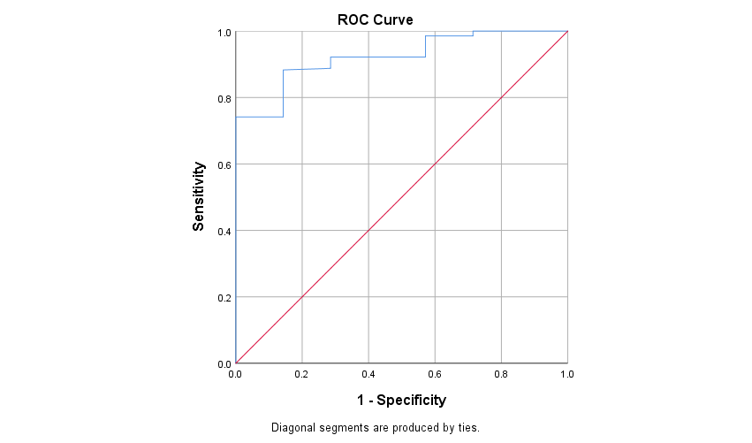
Area Under the Curve
Test Result Variable(s): TRISS
Area | Std. Errorª | Asymptotic Sig.^{b} | Asymptotic 95% Confidence Interval
Area | Std. Errorª | Asymptotic Sig.^{b} | Lower Bound | Upper Bound
.922 | .034 | .000 | .855 | .990
The test result variable(s): TRISS has at least one tie between the positive actual state group and the negatif actual state group. Statistics may be biased.
a. Under the nonparametric assumption
b. Null hypothesis: true area = 0.5

Coordinates of the Curve
Test Result Variable(s): TRISS
Positive if Greater Than or Equal Toª | Sensitivity | 1 - Specificity
.0100 | 1.000 | 1.000
2.1150 | 1.000 | .857
11.8150 | 1.000 | .714
27.5700 | .995 | .714
40.6850 | .990 | .714
46.6850 | .985 | .714
55.0050 | .985 | .571
65.7200 | .980 | .571
70.3100 | .976 | .571
79.9000 | .971 | .571
87.4600 | .966 | .571
87.6350 | .961 | .571
88.9450 | .956 | .571
90.5350 | .951 | .571
91.5150 | .946 | .571
92.4500 | .941 | .571
92.7800 | .937 | .571
93.0200 | .932 | .571
93.8800 | .927 | .571
94.5750 | .922 | .571
94.8150 | .922 | .429
95.0350 | .922 | .286
95.0900 | .917 | .286
95.3150 | .912 | .286
95.5150 | .907 | .286
95.6750 | .902 | .286
95.8350 | .898 | .286
95.8750 | .893 | .286
95.9900 | .888 | .286
96.1250 | .883 | .143
96.3150 | .868 | .143
96.4700 | .859 | .143
96.5500 | .854 | .143
96.6750 | .849 | .143
96.7400 | .844 | .143
96.8450 | .834 | .143
96.9750 | .829 | .143
97.1700 | .820 | .143
97.3650 | .815 | .143
97.4150 | .805 | .143
97.4450 | .800 | .143
97.5400 | .790 | .143
97.6300 | .785 | .143
97.6450 | .780 | .143
97.7450 | .766 | .143
97.9000 | .741 | .143
98.0600 | .741 | .000
98.2150 | .663 | .000
98.2800 | .654 | .000
98.3000 | .644 | .000
98.3600 | .615 | .000
98.4700 | .610 | .000
98.5350 | .605 | .000
98.5950 | .600 | .000
98.7050 | .585 | .000
98.8600 | .580 | .000
98.9950 | .576 | .000
99.0700 | .566 | .000
99.1150 | .551 | .000
99.1850 | .537 | .000
99.2800 | .532 | .000
99.3200 | .527 | .000
99.3450 | .507 | .000
99.3650 | .498 | .000
99.3950 | .473 | .000
99.4350 | .449 | .000
99.4550 | .439 | .000
99.4700 | .429 | .000
99.4950 | .420 | .000
99.5300 | .415 | .000
99.5650 | .395 | .000
99.5950 | .361 | .000
99.6300 | .317 | .000
99.6600 | .302 | .000
99.6850 | .220 | .000
99.7100 | .005 | .000
100.7200 | .000 | .000
The test result variable(s): TRISS has at least one tie between the positive actual state group and the negatif actual state group.
a. The smallest cutoff value is the minimum observed test value minus 1, and the largest cutoff value is the maximum observed test value plus 1. All the other cutoff values are the averages of two consecutive ordered observed test values.

 | Coordinates of the Curve
 | Test Result Variable(s):
 | Positive if Greater Than or Equal Toª | Sensitivity | spesifisitas
1 | 0,0100 | 1,000 | 0,000
2 | 2,1150 | 1,000 | 0,143
3 | 11,8150 | 1,000 | 0,286
4 | 27,5700 | 0,995 | 0,286
5 | 40,6850 | 0,990 | 0,286
6 | 46,6850 | 0,985 | 0,286
7 | 55,0050 | 0,985 | 0,429
8 | 65,7200 | 0,980 | 0,429
9 | 70,3100 | 0,976 | 0,429
10 | 79,9000 | 0,971 | 0,429
11 | 87,4600 | 0,966 | 0,429
12 | 87,6350 | 0,961 | 0,429
13 | 88,9450 | 0,956 | 0,429
14 | 90,5350 | 0,951 | 0,429
15 | 91,5150 | 0,946 | 0,429
16 | 92,4500 | 0,941 | 0,429
17 | 92,7800 | 0,937 | 0,429
18 | 93,0200 | 0,932 | 0,429
19 | 93,8800 | 0,927 | 0,429
20 | 94,5750 | 0,922 | 0,429
21 | 94,8150 | 0,922 | 0,571
22 | 95,0350 | 0,922 | 0,714
23 | 95,0900 | 0,917 | 0,714
24 | 95,3150 | 0,912 | 0,714
25 | 95,5150 | 0,907 | 0,714
26 | 95,6750 | 0,902 | 0,714
27 | 95,8350 | 0,898 | 0,714
28 | 95,8750 | 0,893 | 0,714
29 | 95,9900 | 0,888 | 0,714
30 | 96,1250 | 0,883 | 0,857
31 | 96,3150 | 0,868 | 0,857
32 | 96,4700 | 0,859 | 0,857
33 | 96,5500 | 0,854 | 0,857
34 | 96,6750 | 0,849 | 0,857
35 | 96,7400 | 0,844 | 0,857
36 | 96,8450 | 0,834 | 0,857
37 | 96,9750 | 0,829 | 0,857
38 | 97,1700 | 0,820 | 0,857
39 | 97,3650 | 0,815 | 0,857
40 | 97,4150 | 0,805 | 0,857
41 | 97,4450 | 0,800 | 0,857
42 | 97,5400 | 0,790 | 0,857
43 | 97,6300 | 0,785 | 0,857
44 | 97,6450 | 0,780 | 0,857
45 | 97,7450 | 0,766 | 0,857
46 | 97,9000 | 0,741 | 0,857
47 | 98,0600 | 0,741 | 1,000
48 | 98,2150 | 0,663 | 1,000
49 | 98,2800 | 0,654 | 1,000
50 | 98,3000 | 0,644 | 1,000
51 | 98,3600 | 0,615 | 1,000
52 | 98,4700 | 0,610 | 1,000
53 | 98,5350 | 0,605 | 1,000
54 | 98,5950 | 0,600 | 1,000
55 | 98,7050 | 0,585 | 1,000
56 | 98,8600 | 0,580 | 1,000
57 | 98,9950 | 0,576 | 1,000
58 | 99,0700 | 0,566 | 1,000
59 | 99,1150 | 0,551 | 1,000
60 | 99,1850 | 0,537 | 1,000
61 | 99,2800 | 0,532 | 1,000
62 | 99,3200 | 0,527 | 1,000
63 | 99,3450 | 0,507 | 1,000
64 | 99,3650 | 0,498 | 1,000
65 | 99,3950 | 0,473 | 1,000
66 | 99,4350 | 0,449 | 1,000
67 | 99,4550 | 0,439 | 1,000
68 | 99,4700 | 0,429 | 1,000
69 | 99,4950 | 0,420 | 1,000
70 | 99,5300 | 0,415 | 1,000
71 | 99,5650 | 0,395 | 1,000
72 | 99,5950 | 0,361 | 1,000
73 | 99,6300 | 0,317 | 1,000
74 | 99,6600 | 0,302 | 1,000
75 | 99,6850 | 0,220 | 1,000
76 | 99,7100 | 0,005 | 1,000
77 | 100,7200 | 0,000 | 1,000
 | The test result variable(s): TRISS has at least one tie between the positive actual state group and the negatif actual state group.
 | a. The smallest cutoff value is the minimum observed test value minus 1, and the largest cutoff value is the maximum observed test value plus 1. All the other cutoff values are the averages of two consecutive ordered observed test values.

GAP SCORE

Classification Table^{a,b}
 | Observed |  | Predicted
 |  |  | survival |  | Percentage Correct
 |  |  | meninggal | survival | Percentage Correct
Step 0 | survival | meninggal | 2 | 5 | 28.6
Step 0 | survival | survival | 4 | 201 | 99
Step 0 | Overall Percentage |  |  |  | 95.7
a. Constant is included in the model.
b. The cut value is ,500

Case Processing Summary
survival | Valid N (listwise)
Positiveª | 205
Negative | 7
Larger values of the test result variable(s) indicate stronger evidence for a positive actual state.
a. The positive actual state is survival.

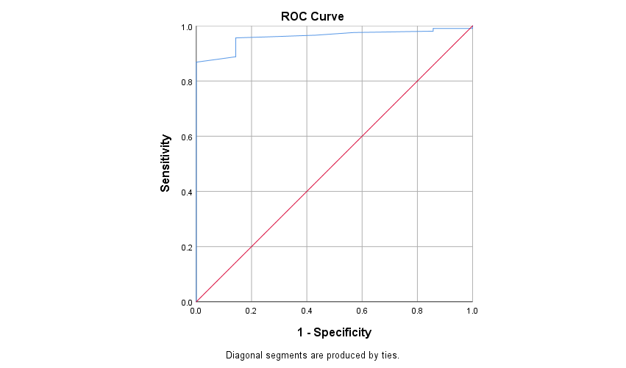

Area Under the Curve
Test Result Variable(s): GAP
Area | Std. Errorª | Asymptotic Sig.^{b} | Asymptotic 95% Confidence Interval
Area | Std. Errorª | Asymptotic Sig.^{b} | Lower Bound | Upper Bound
.960 | .017 | .000 | .926 | .993
The test result variable(s): GAP has at least one tie between the positive actual state group and the negatif actual state group. Statistics may be biased.
a. Under the nonparametric assumption
b. Null hypothesis: true area = 0.5

Coordinates of the Curve
Test Result Variable(s): GAP
Positive if Greater Than or Equal Toª | Sensitivity | 1 - Specificity
-1.0000 | 1.000 | 1.000
4.0000 | .990 | 1.000
9.0000 | .990 | .857
10.5000 | .980 | .857
12.0000 | .976 | .571
13.5000 | .966 | .429
14.5000 | .956 | .143
15.5000 | .937 | .143
16.5000 | .888 | .143
17.5000 | .868 | .000
18.5000 | .805 | .000
19.5000 | .771 | .000
20.5000 | .654 | .000
21.5000 | .639 | .000
22.5000 | .605 | .000
23.5000 | .254 | .000
24.5000 | .239 | .000
26.0000 | .000 | .000
The test result variable(s): GAP has at least one tie between the positive actual state group and the negatif actual state group.
a. The smallest cutoff value is the minimum observed test value minus 1, and the largest cutoff value is the maximum observed test value plus 1. All the other cutoff values are the averages of two consecutive ordered observed test values.
 | Coordinates of the Curve
 | Test Result Variable(s):
 | Positive if Greater Than or Equal Toª | Sensitivity | spesifisitas
1 | -1,0000 | 1,000 | 0,000
2 | 4,0000 | 0,990 | 0,000
3 | 9,0000 | 0,990 | 0,143
4 | 10,5000 | 0,980 | 0,143
5 | 12,0000 | 0,976 | 0,429
6 | 13,5000 | 0,966 | 0,571
7 | 14,5000 | 0,956 | 0,857
8 | 15,5000 | 0,937 | 0,857
9 | 16,5000 | 0,888 | 0,857
10 | 17,5000 | 0,868 | 1,000
11 | 18,5000 | 0,805 | 1,000
12 | 19,5000 | 0,771 | 1,000
13 | 20,5000 | 0,654 | 1,000
14 | 21,5000 | 0,639 | 1,000
15 | 22,5000 | 0,605 | 1,000
16 | 23,5000 | 0,254 | 1,000
17 | 24,5000 | 0,239 | 1,000
18 | 26,0000 | 0,000 | 1,000
 | The test result variable(s): GAP has at least one tie between the positive actual state group and the negatif actual state group.
 | a. The smallest cutoff value is the minimum observed test value minus 1, and the largest cutoff value is the maximum observed test value plus 1. All the other cutoff values are the averages of two consecutive ordered observed test values.

KTS

Classification Tableª
 | Observed |  | Predicted
 |  |  | survival |  | Percentage Correct
 |  |  | meninggal | survival | Percentage Correct
Step 1 | survival | Meninggal | 5 | 2 | 98.0
Step 1 | survival | survival | 4 | 201 | 71.4
Step 1 | Overall Percentage |  |  |  | 97.4
a. The cut value is ,500

Case Processing Summary
survival | Valid N (listwise)
Positiveª | 205
Negative | 7
Larger values of the test result variable(s) indicate stronger evidence for a positive actual state.
a. The positive actual state is survival.

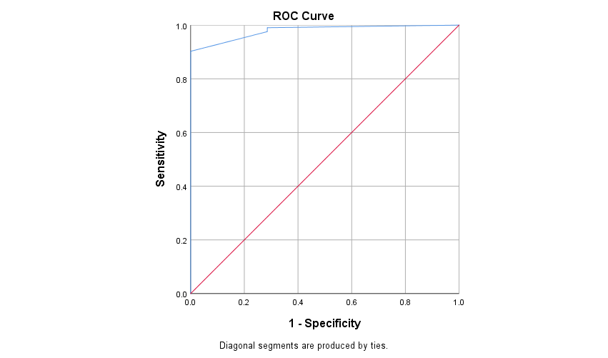

Area Under the Curve
Test Result Variable(s): KTS
Area | Std. Errorª | Asymptotic Sig.^{b} | Asymptotic 95% Confidence Interval
Area | Std. Errorª | Asymptotic Sig.^{b} | Lower Bound | Upper Bound
.979 | .012 | .000 | .955 | 1.000
The test result variable(s): KTS has at least one tie between the positive actual state group and the negatif actual state group. Statistics may be biased.
a. Under the nonparametric assumption
b. Null hypothesis: true area = 0.5

Coordinates of the Curve
Test Result Variable(s): KTS
Positive if Greater Than or Equal Toª | Sensitivity | 1 - Specificity
2.0000 | 1.000 | 1.000
3.5000 | .990 | .286
4.5000 | .976 | .286
5.5000 | .902 | .000
6.5000 | .859 | .000
7.5000 | .810 | .000
8.5000 | .717 | .000
9.5000 | .551 | .000
11.0000 | .000 | .000
The test result variable(s): KTS has at least one tie between the positive actual state group and the negatif actual state group.
a. The smallest cutoff value is the minimum observed test value minus 1, and the largest cutoff value is the maximum observed test value plus 1. All the other cutoff values are the averages of two consecutive ordered observed test values.

 | Coordinates of the Curve
 | Test Result Variable(s):
 | Positive if Greater Than or Equal Toª | Sensitivity | spesifisitas
1 | 2,0000 | 1,000 | 0,000
2 | 3,5000 | 0,990 | 0,714
3 | 4,5000 | 0,976 | 0,714
4 | 5,5000 | 0,902 | 1,000
5 | 6,5000 | 0,859 | 1,000
6 | 7,5000 | 0,810 | 1,000
7 | 8,5000 | 0,717 | 1,000
8 | 9,5000 | 0,551 | 1,000
9 | 11,0000 | 0,000 | 1,000
 | The test result variable(s): KTS has at least one tie between the positive actual state group and the negatif actual state group.
 | a. The smallest cutoff value is the minimum observed test value minus 1, and the largest cutoff value is the maximum observed test value plus 1. All the other cutoff values are the averages of two consecutive ordered observed test values.

