Articles excluded as irrelevant through abstract screening on the grounds of:
- Articles were not in English/Indonesian language (n=21).
- Sample was not pregnant women (n=127)
- Review/Editorial/Report (n=91) 4.
- No full text available (n=39)
- Inappropriate intervention (n=112)
- Not an RCT article (n=9)
The results of the article search using the words calcium supplement, blood pressure, pregnant women, hypertension, pre-eclampsia database Pubmed, Google Scholar, Elsevier
(n=1086.)
Articles after duplication is removed (n= 439)
Articles after title and abstract filter (n=29)
Article screening based on full text and eligibility criteria
Excluded articles due to duplication (n=674)
Full-text articles that were discarded for reasons:
Not included blood pressure results (n=24)

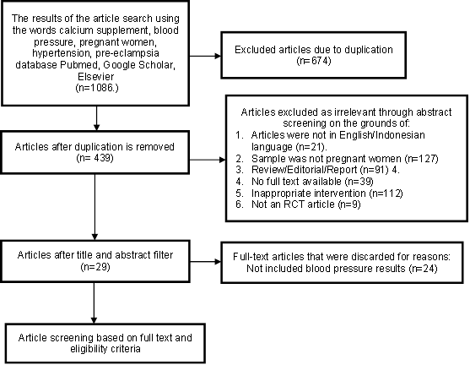
Figure 1. Screening Flow Diagram
Figure 2. Flow diagram of calcium intervention
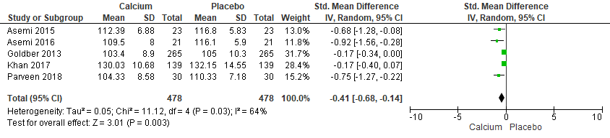
Figure 3. Forest plot
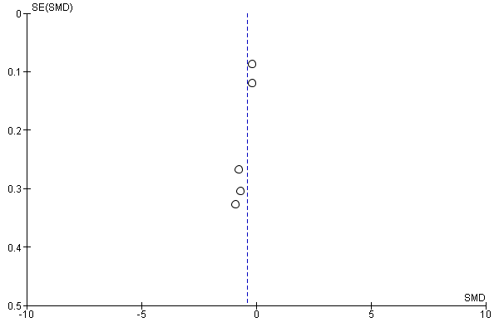

Table 1. Critical Appraisal Assestment
Assessment Item | Publications
Assessment Item | Asemi (2015) | Asemi (2016) | Goldber (2013) | Khan (2017) | Parveen  (2018)
Relevance of objectives and problem | 1 | 1 | 1 | 1 | 1
Relevance of the method and problem | 1 | 1 | 1 | 1 | 1
Sufficient samples | 1 | 1 | 1 | 1 | 1
Validation of samples | 1 | 1 | 1 | 1 | 1
Comparable Cases and Controls | 1 | 1 | 1 | 1 | 1
No bias | 1 | 0 | 1 | 1 | 1
Information data tracking | 1 | 1 | 1 | 1 | 1
Analysis of relevant and valid data | 1 | 1 | 1 | 1 | 1
Relevance Effect Size | 1 | 1 | 1 | 1 | 1
Reporting 95% CI | 1 | 1 | 1 | 1 | 1
Reported confounding factors | 1 | 1 | 1 | 0 | 1
Results can be applied | 1 | 1 | 1 | 1 | 1
Total | 12 | 11 | 12 | 11 | 12

Tabel 2. PICO Screening
No | Nama Peneliti | P  (Population) | I  (Intervention) | C  (Comparison) | O  (Outcome)
1 | Asemi (2015) | 46 Pregnant women at risk of pre-eclampsia.  25 weeks  Gestation  27 weeks gestation  (23 intervention; 23 control) | Calcium 800 mg  Magnesium 200 mg  Zinc 8 mg  Vit. D3 400 IU  For 9 weeks | Placebo  For 9 weeks | Multi mineral group+ Vit. D  SBP: 113.47±4.86 decreased 112.39±6.88 (mean decrease -1.08, ρ =0.34)  DBP: 66.30±6.43 decreased to 65.86±7.17 (mean decrease -0.44)ρ =0.70  Placebo group  SBP: 110.00±6.03 increased to 116.08±5.83 (mean difference 6.08 with ρ =0.001)  DBP: 66.95±5.38 increased to 70.00±5.83 (mean difference 3.05, with ρ = 0.007)
2 | Asemi (2016) | Study subjects 42 healthy pregnant womens  Aged 18-40 years  25 weeks gestational  21 control, 21 intervention | Calcium Carbonate 500 mg+200Iu Vit.D/day  for 9 weeks | Placebo  for 9 weeks | Intervention Systole  106.9±5.3 increased to 109.5±8.0 (difference 2.6±8.7)  Control  109.5±5.9 increased to 116.1±5.9  ρ value = 0.11  Diastole Intervention: 65.7±5.0 to 63.8±5.5 (decrease 1.9±3.3)  Placebo  and diastole 66.7±5.5 to 69.8±6.0 (increase 3.1±5.2)  ρ value = 0.02
3 | Goldber (2013) | Study subjects were 272 nulliparas; (123 intervention; 139 control)  Pregnant women with BP <140/90 mmHg and proteinuria (-) | Intervention: 2 g/hr (4 500 mg tablets); Started at 20 weeks gestation until delivery. | Control: 500 mg/hr.( 4 Tablets =1 Ca tablet, 3 Placebo) | Patient satisfaction questionnaire standard
4 | Khan (2017) | Study subjects were 272 nulliparas;  (123 intervention; 139 control)  Pregnant women with BP <140/90 mmHg and proteinuria (-) | Intervention: 2 gr/hr (4 500 mg tablets);  Started at 20 weeks gestation until delivery | Control: 500 mg/hr.( 4 Tablets =1 Ca tablet, 3 Placebo) | Mean SBP:  Intervention Group: 130.03 ± 10.68  Control Group: 132.15 ± 14.55  (p=0.0001)  Mean DBP:  Intervention Group: 81.44 ± 8.65  Control Group: 83.94 ± 12.54  (p=0.0009)
5 | Praveen (2018) | 60 pregnant women  (30 group A; 30 group B) | Group A: Low dose calcium 500 mg 2x daily  from 17-20 weeks of pregnancy until delivery | Group A: Low dose calcium 500 mg 2x daily  from 17-20 weeks of pregnancy until delivery | Group A (Low Dose)  SBP:  Pre: 109.33±10.14; post: 110.33±7.18 (increase of 1 mmHg, ρ 0.586)  DBP:  Pre : 72.667±10.80; post: 76.33±5.56 (increase 3.663mmHg, ρ 0.125)  Group B (High Dose)  SBP:  Pre: 125.00±13.8; post: 104.333±8.58 (decrease 20.67 mmHg, ρ 0.0001)  DBP = 84.33±9.35; post: 69.667±7.64 (decreased 14.66mmHg, ρ 0.0002)

c

