Supplementary
T- Value
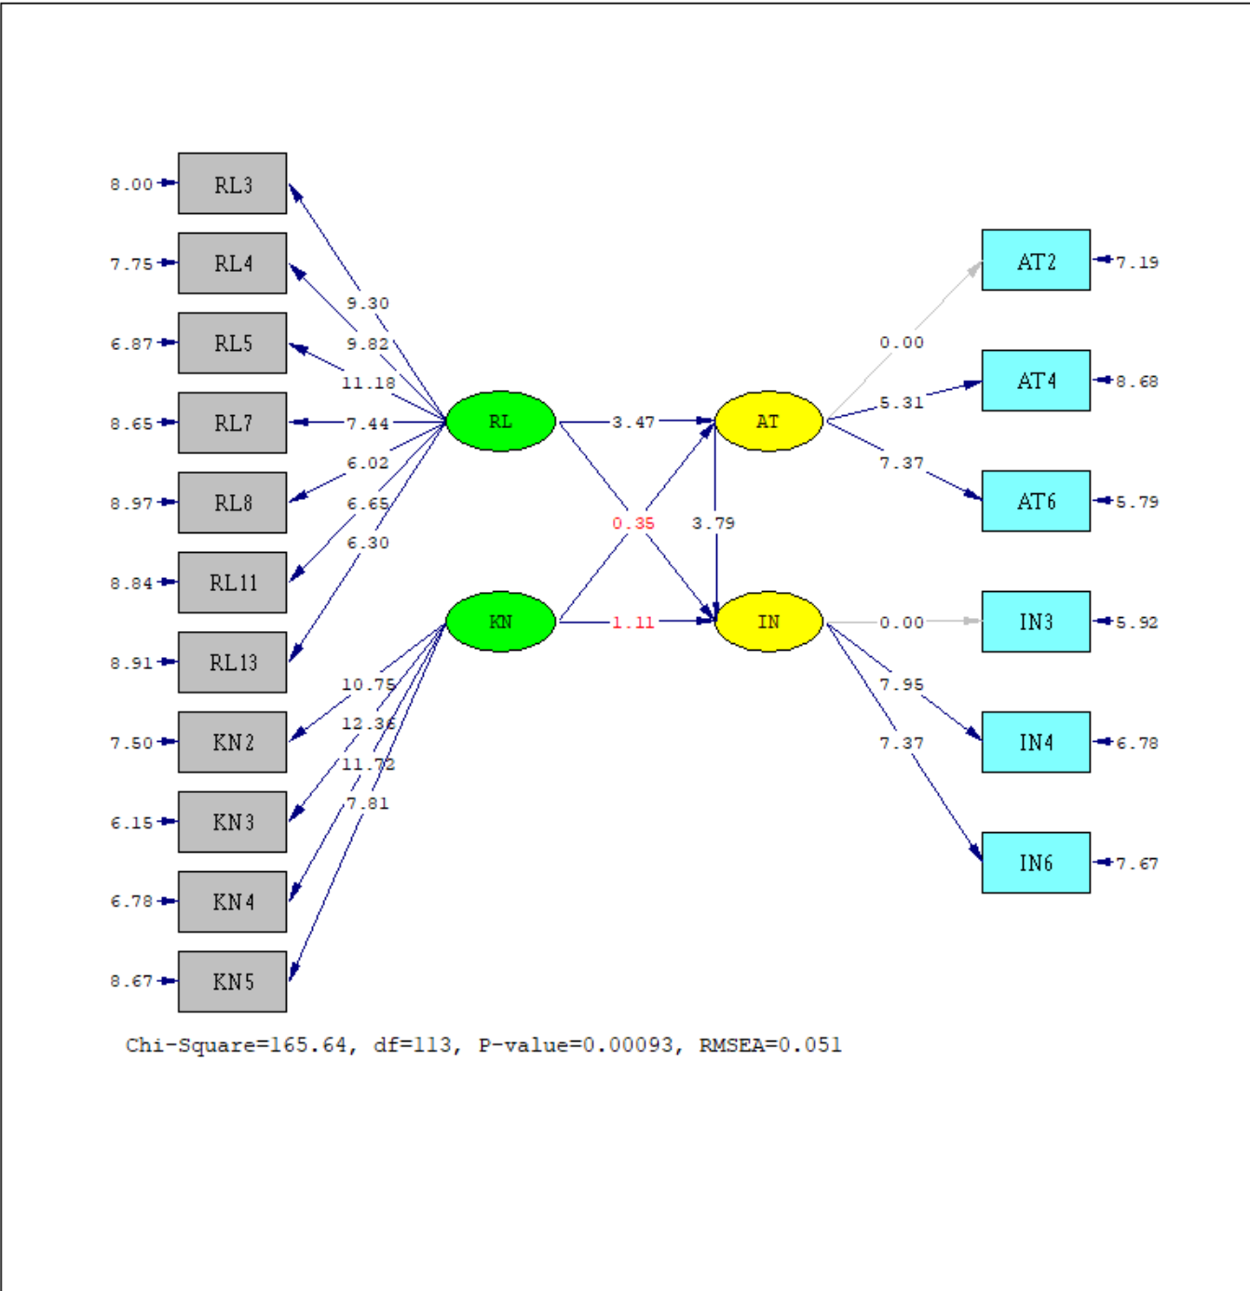

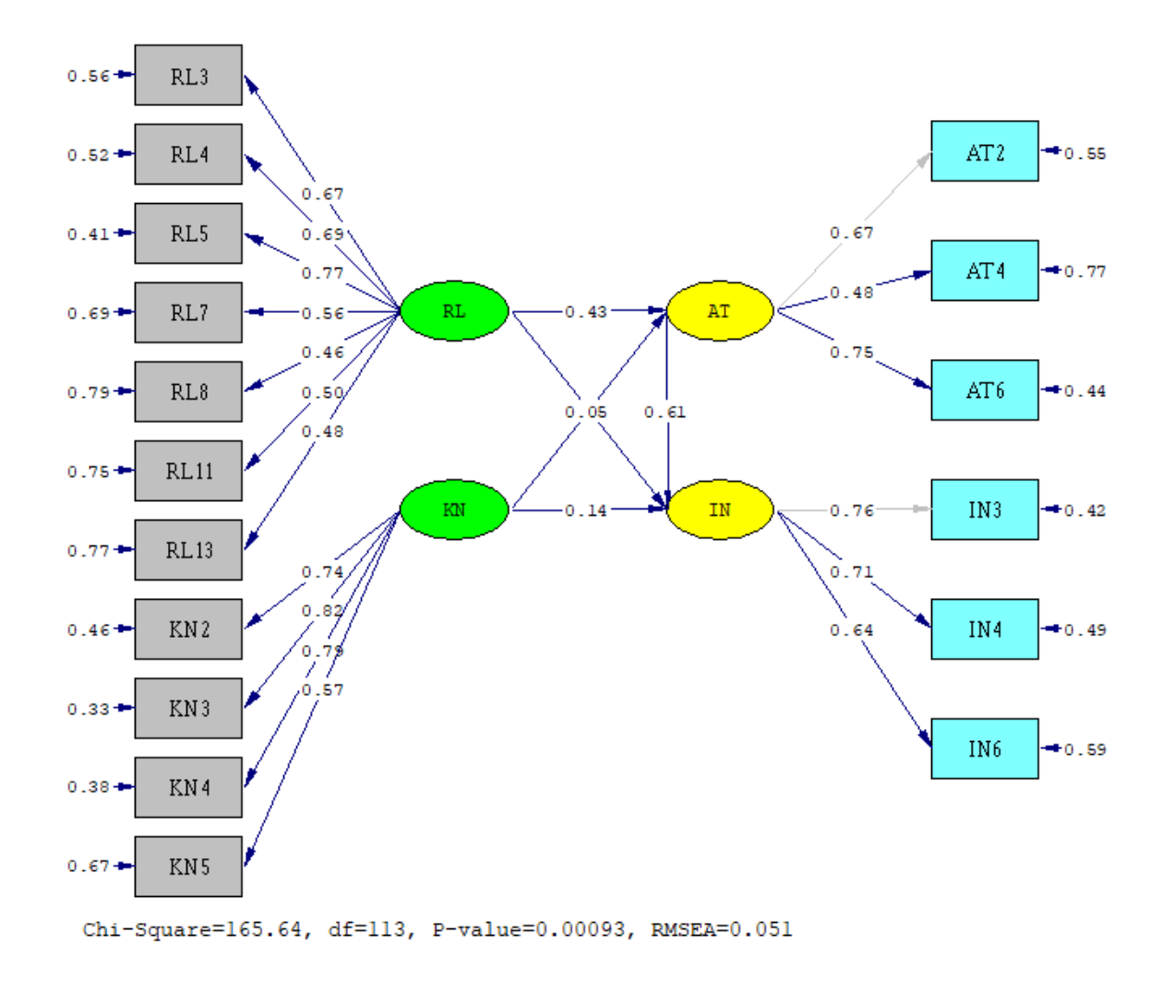
Standardized Solution

Output
DATE: 5/ 2/2025
TIME: 10:29

L I S R E L 8.70

BY

Karl G. Jöreskog & Dag Sörbom

This program is published exclusively by
Scientific Software International, Inc.
7383 N. Lincoln Avenue, Suite 100
Lincolnwood, IL 60712, U.S.A.
Phone: (800)247-6113, (847)675-0720, Fax: (847)675-2140
Copyright by Scientific Software International, Inc., 1981-2004
Use of this program is subject to the terms specified in the
Universal Copyright Convention.
Website: www.ssicentral.com

The following lines were read from file D:\Liserel\2. Produk Halal 3\Halal Path.SPJ:

SYSTEM FILE from file 'D:\Liserel\2. Produk Halal 3\Halal Path.DSF'
Sample Size = 180
Latent Variables AT IN RL KN
Relationships
AT2 = 0.36*AT
AT4 = AT
AT6 = AT
IN3 = 0.32*IN
IN4 = IN
IN6 = IN
RL3 = RL
RL4 = RL
RL5 = RL
RL7 = RL
RL8 = RL
RL11 = RL
RL13 = RL
KN2 = KN
KN3 = KN
KN4 = KN
KN5 = KN
IN = AT
AT = RL KN
IN = RL KN
IN = AT RL KN
LISREL OUTPUT: EF SS SC
Set the Variance of RL to 1.00
Set the Variance of KN to 1.00
Path Diagram
End of Problem

Covariance Matrix

AT2 AT4 AT6 IN3 IN4 IN6
-------- -------- -------- -------- -------- --------
AT2 0.29
AT4 0.05 0.11
AT6 0.18 0.08 0.40
IN3 0.09 0.05 0.10 0.18
IN4 0.16 0.06 0.16 0.15 0.44
IN6 0.08 0.04 0.07 0.11 0.13 0.22
RL3 0.08 0.02 0.12 0.07 0.12 0.07
RL4 0.06 0.03 0.10 0.06 0.11 0.05
RL5 0.11 0.04 0.16 0.06 0.13 0.05
RL7 0.12 0.04 0.15 0.08 0.12 0.07
RL8 0.02 0.01 0.05 0.05 0.04 0.03
RL11 0.03 0.02 0.07 0.01 0.02 0.02
RL13 0.05 0.04 0.08 0.04 0.08 0.01
KN2 0.08 0.03 0.08 0.04 0.07 0.06
KN3 0.07 0.04 0.11 0.05 0.13 0.08
KN4 0.08 0.03 0.12 0.06 0.11 0.06
KN5 0.11 0.07 0.17 0.08 0.17 0.09

Covariance Matrix

RL3 RL4 RL5 RL7 RL8 RL11
-------- -------- -------- -------- -------- --------
RL3 0.43
RL4 0.14 0.24
RL5 0.20 0.14 0.33
RL7 0.18 0.14 0.18 0.55
RL8 0.09 0.07 0.07 0.11 0.15
RL11 0.08 0.06 0.09 0.05 0.04 0.12
RL13 0.10 0.08 0.09 0.08 0.03 0.06
KN2 0.06 0.09 0.09 0.06 0.01 0.04
KN3 0.10 0.12 0.12 0.10 0.02 0.04
KN4 0.09 0.11 0.11 0.09 0.03 0.04
KN5 0.07 0.11 0.11 0.12 0.02 0.02

Covariance Matrix

RL13 KN2 KN3 KN4 KN5
-------- -------- -------- -------- --------
RL13 0.22
KN2 0.06 0.18
KN3 0.07 0.14 0.28
KN4 0.05 0.12 0.17 0.24
KN5 0.03 0.15 0.16 0.14 0.51

Parameter Specifications

LAMBDA-Y

AT IN
-------- --------
AT2 0 0
AT4 1 0
AT6 2 0
IN3 0 0
IN4 0 3
IN6 0 4

LAMBDA-X

RL KN
-------- --------
RL3 5 0
RL4 6 0
RL5 7 0
RL7 8 0
RL8 9 0
RL11 10 0
RL13 11 0
KN2 0 12
KN3 0 13
KN4 0 14
KN5 0 15

BETA

AT IN
-------- --------
AT 0 0
IN 16 0

GAMMA

RL KN
-------- --------
AT 17 18
IN 19 20

PHI

RL KN
-------- --------
RL 0
KN 21 0

PSI

AT IN
-------- --------
22 23

THETA-EPS

AT2 AT4 AT6 IN3 IN4 IN6
-------- -------- -------- -------- -------- --------
24 25 26 27 28 29

THETA-DELTA

RL3 RL4 RL5 RL7 RL8 RL11
-------- -------- -------- -------- -------- --------
30 31 32 33 34 35

THETA-DELTA

RL13 KN2 KN3 KN4 KN5
-------- -------- -------- -------- --------
36 37 38 39 40

Number of Iterations = 19

LISREL Estimates (Maximum Likelihood)

LAMBDA-Y

AT IN
-------- --------
AT2 0.36 - -

AT4 0.16 - -
(0.03)
5.31

AT6 0.47 - -
(0.06)
7.37

IN3 - - 0.32

IN4 - - 0.47
(0.06)
7.95

IN6 - - 0.30
(0.04)
7.37

LAMBDA-X

RL KN
-------- --------
RL3 0.44 - -
(0.05)
9.30

RL4 0.34 - -
(0.03)
9.82

RL5 0.44 - -
(0.04)
11.18

RL7 0.41 - -
(0.06)
7.44

RL8 0.18 - -
(0.03)
6.02

RL11 0.18 - -
(0.03)
6.65

RL13 0.23 - -
(0.04)
6.30

KN2 - - 0.32
(0.03)
10.75

KN3 - - 0.43
(0.04)
12.36

KN4 - - 0.38
(0.03)
11.72

KN5 - - 0.41
(0.05)
7.81

BETA

AT IN
-------- --------
AT - - - -

IN 0.61 - -
(0.16)
3.79

GAMMA

RL KN
-------- --------
AT 0.43 0.34
(0.12) (0.12)
3.47 2.81

IN 0.05 0.14
(0.13) (0.12)
0.35 1.11

Covariance Matrix of ETA and KSI

AT IN RL KN
-------- -------- -------- --------
AT 1.01
IN 0.73 1.02
RL 0.64 0.52 1.00
KN 0.60 0.54 0.62 1.00

PHI

RL KN
-------- --------
RL 1.00

KN 0.62 1.00
(0.06)
10.02

PSI
Note: This matrix is diagonal.

AT IN
-------- --------
0.53 0.47
(0.14) (0.12)
3.74 3.82

Squared Multiple Correlations for Structural Equations

AT IN
-------- --------
0.47 0.54

Squared Multiple Correlations for Reduced Form

AT IN
-------- --------
0.47 0.34

Reduced Form

RL KN
-------- --------
AT 0.43 0.34
(0.12) (0.12)
3.47 2.81

IN 0.31 0.34
(0.12) (0.12)
2.56 2.87

THETA-EPS

AT2 AT4 AT6 IN3 IN4 IN6
-------- -------- -------- -------- -------- --------
0.16 0.09 0.17 0.08 0.21 0.13
(0.02) (0.01) (0.03) (0.01) (0.03) (0.02)
7.19 8.68 5.79 5.92 6.78 7.67

Squared Multiple Correlations for Y - Variables

AT2 AT4 AT6 IN3 IN4 IN6
-------- -------- -------- -------- -------- --------
0.45 0.23 0.56 0.58 0.51 0.41

THETA-DELTA

RL3 RL4 RL5 RL7 RL8 RL11
-------- -------- -------- -------- -------- --------
0.24 0.13 0.14 0.38 0.12 0.09
(0.03) (0.02) (0.02) (0.04) (0.01) (0.01)
8.00 7.75 6.87 8.65 8.97 8.84

THETA-DELTA

RL13 KN2 KN3 KN4 KN5
-------- -------- -------- -------- --------
0.17 0.08 0.09 0.09 0.34
(0.02) (0.01) (0.02) (0.01) (0.04)
8.91 7.50 6.15 6.78 8.67

Squared Multiple Correlations for X - Variables

RL3 RL4 RL5 RL7 RL8 RL11
-------- -------- -------- -------- -------- --------
0.44 0.48 0.59 0.31 0.21 0.25

Squared Multiple Correlations for X - Variables

RL13 KN2 KN3 KN4 KN5
-------- -------- -------- -------- --------
0.23 0.54 0.67 0.62 0.33

Goodness of Fit Statistics

Degrees of Freedom = 113
Minimum Fit Function Chi-Square = 175.32 (P = 0.00016)
Normal Theory Weighted Least Squares Chi-Square = 165.64 (P = 0.00093)
Estimated Non-centrality Parameter (NCP) = 52.64
90 Percent Confidence Interval for NCP = (22.21 ; 91.06)

Minimum Fit Function Value = 0.98
Population Discrepancy Function Value (F0) = 0.29
90 Percent Confidence Interval for F0 = (0.12 ; 0.51)
Root Mean Square Error of Approximation (RMSEA) = 0.051
90 Percent Confidence Interval for RMSEA = (0.033 ; 0.067)
P-Value for Test of Close Fit (RMSEA < 0.05) = 0.44

Expected Cross-Validation Index (ECVI) = 1.37
90 Percent Confidence Interval for ECVI = (1.20 ; 1.59)
ECVI for Saturated Model = 1.71
ECVI for Independence Model = 13.54

Chi-Square for Independence Model with 136 Degrees of Freedom = 2389.50
Independence AIC = 2423.50
Model AIC = 245.64
Saturated AIC = 306.00
Independence CAIC = 2494.78
Model CAIC = 413.36
Saturated CAIC = 947.52

Normed Fit Index (NFI) = 0.93
Non-Normed Fit Index (NNFI) = 0.97
Parsimony Normed Fit Index (PNFI) = 0.77
Comparative Fit Index (CFI) = 0.97
Incremental Fit Index (IFI) = 0.97
Relative Fit Index (RFI) = 0.91

Critical N (CN) = 155.05

Root Mean Square Residual (RMR) = 0.016
Standardized RMR = 0.059
Goodness of Fit Index (GFI) = 0.90
Adjusted Goodness of Fit Index (AGFI) = 0.87
Parsimony Goodness of Fit Index (PGFI) = 0.67

Standardized Solution

LAMBDA-Y

AT IN
-------- --------
AT2 0.36 - -
AT4 0.16 - -
AT6 0.47 - -
IN3 - - 0.32
IN4 - - 0.47
IN6 - - 0.30

LAMBDA-X

RL KN
-------- --------
RL3 0.44 - -
RL4 0.34 - -
RL5 0.44 - -
RL7 0.41 - -
RL8 0.18 - -
RL11 0.18 - -
RL13 0.23 - -
KN2 - - 0.32
KN3 - - 0.43
KN4 - - 0.38
KN5 - - 0.41

BETA

AT IN
-------- --------
AT - - - -
IN 0.61 - -

GAMMA

RL KN
-------- --------
AT 0.43 0.34
IN 0.05 0.14

Correlation Matrix of ETA and KSI

AT IN RL KN
-------- -------- -------- --------
AT 1.00
IN 0.72 1.00
RL 0.64 0.52 1.00
KN 0.60 0.53 0.62 1.00

PSI
Note: This matrix is diagonal.

AT IN
-------- --------
0.53 0.46

Regression Matrix ETA on KSI (Standardized)

RL KN
-------- --------
AT 0.43 0.34
IN 0.31 0.34

Completely Standardized Solution

LAMBDA-Y

AT IN
-------- --------
AT2 0.67 - -
AT4 0.48 - -
AT6 0.75 - -
IN3 - - 0.76
IN4 - - 0.71
IN6 - - 0.64

LAMBDA-X

RL KN
-------- --------
RL3 0.67 - -
RL4 0.69 - -
RL5 0.77 - -
RL7 0.56 - -
RL8 0.46 - -
RL11 0.50 - -
RL13 0.48 - -
KN2 - - 0.74
KN3 - - 0.82
KN4 - - 0.79
KN5 - - 0.57

BETA

AT IN
-------- --------
AT - - - -
IN 0.61 - -

GAMMA

RL KN
-------- --------
AT 0.43 0.34
IN 0.05 0.14

Correlation Matrix of ETA and KSI

AT IN RL KN
-------- -------- -------- --------
AT 1.00
IN 0.72 1.00
RL 0.64 0.52 1.00
KN 0.60 0.53 0.62 1.00

PSI
Note: This matrix is diagonal.

AT IN
-------- --------
0.53 0.46

THETA-EPS

AT2 AT4 AT6 IN3 IN4 IN6
-------- -------- -------- -------- -------- --------
0.55 0.77 0.44 0.42 0.49 0.59

THETA-DELTA

RL3 RL4 RL5 RL7 RL8 RL11
-------- -------- -------- -------- -------- --------
0.56 0.52 0.41 0.69 0.79 0.75

THETA-DELTA

RL13 KN2 KN3 KN4 KN5
-------- -------- -------- -------- --------
0.77 0.46 0.33 0.38 0.67

Regression Matrix ETA on KSI (Standardized)

RL KN
-------- --------
AT 0.43 0.34
IN 0.31 0.34

Total and Indirect Effects

Total Effects of KSI on ETA

RL KN
-------- --------
AT 0.43 0.34
(0.12) (0.12)
3.47 2.81

IN 0.31 0.34
(0.12) (0.12)
2.56 2.87

Indirect Effects of KSI on ETA

RL KN
-------- --------
AT - - - -

IN 0.26 0.21
(0.10) (0.09)
2.64 2.35

Total Effects of ETA on ETA

AT IN
-------- --------
AT - - - -

IN 0.61 - -
(0.16)
3.79

Largest Eigenvalue of B*B' (Stability Index) is 0.373

Total Effects of ETA on Y

AT IN
-------- --------
AT2 0.36 - -

AT4 0.16 - -
(0.03)
5.31

AT6 0.47 - -
(0.06)
7.37

IN3 0.20 0.32
(0.05)
3.79

IN4 0.29 0.47
(0.08) (0.06)
3.74 7.95

IN6 0.18 0.30
(0.05) (0.04)
3.66 7.37

Indirect Effects of ETA on Y

AT IN
-------- --------
AT2 - - - -

AT4 - - - -

AT6 - - - -

IN3 0.20 - -
(0.05)
3.79

IN4 0.29 - -
(0.08)
3.74

IN6 0.18 - -
(0.05)
3.66

Total Effects of KSI on Y

RL KN
-------- --------
AT2 0.15 0.12
(0.04) (0.04)
3.47 2.81

AT4 0.07 0.05
(0.02) (0.02)
3.18 2.65

AT6 0.20 0.16
(0.06) (0.06)
3.55 2.85

IN3 0.10 0.11
(0.04) (0.04)
2.56 2.87

IN4 0.14 0.16
(0.06) (0.06)
2.54 2.84

IN6 0.09 0.10
(0.04) (0.04)
2.52 2.81

Standardized Total and Indirect Effects

Standardized Total Effects of KSI on ETA

RL KN
-------- --------
AT 0.43 0.34
IN 0.31 0.34

Standardized Indirect Effects of KSI on ETA

RL KN
-------- --------
AT - - - -
IN 0.26 0.20

Standardized Total Effects of ETA on ETA

AT IN
-------- --------
AT - - - -
IN 0.61 - -

Standardized Total Effects of ETA on Y

AT IN
-------- --------
AT2 0.36 - -
AT4 0.16 - -
AT6 0.47 - -
IN3 0.20 0.32
IN4 0.29 0.47
IN6 0.19 0.30

Completely Standardized Total Effects of ETA on Y

AT IN
-------- --------
AT2 0.67 - -
AT4 0.48 - -
AT6 0.75 - -
IN3 0.46 0.76
IN4 0.43 0.71
IN6 0.39 0.64

Standardized Indirect Effects of ETA on Y

AT IN
-------- --------
AT2 - - - -
AT4 - - - -
AT6 - - - -
IN3 0.20 - -
IN4 0.29 - -
IN6 0.19 - -

Completely Standardized Indirect Effects of ETA on Y

AT IN
-------- --------
AT2 - - - -
AT4 - - - -
AT6 - - - -
IN3 0.46 - -
IN4 0.43 - -
IN6 0.39 - -

Standardized Total Effects of KSI on Y

RL KN
-------- --------
AT2 0.15 0.12
AT4 0.07 0.05
AT6 0.20 0.16
IN3 0.10 0.11
IN4 0.14 0.16
IN6 0.09 0.10

Completely Standardized Total Effects of KSI on Y

RL KN
-------- --------
AT2 0.29 0.23
AT4 0.20 0.16
AT6 0.32 0.25
IN3 0.23 0.26
IN4 0.22 0.24
IN6 0.20 0.22

Time used: 0.063 Seconds

