LETTER OF APPROVAL OF SCIENTIFIC MANUSCRIPT PUBLICATION
Signed below:
Author:
1. Name : Sophia Denta Prapdika Sari email : dentasophia@student.uns.ac.id
2. Name : Ida Nurwati email : idanurwati@staff.uns.ac.id
3. Name : Ratih Puspita Febrinasari email : ratihpuspita@staff.uns.ac.id

Corresponing author’s name and email address:
Name : Sophia Denta Prapdika Sari
Email : dentasophia@student.uns.ac.id

States that the scientific text:
The Potential Of Pisang Raja As A Functional Food In Reducing BMI And Fat Percent In Hypertension Patients

The above manuscript has been examined by the advisers and authors, contains no fabrication, falsification, and plagiarism, and has been approved the final form of the manuscript by all authors to be published through our agreement in Jurnal Gizi dan Dietetik Indonesia (Indonesian Journal of Nutrition and Dietetics).
- In order to maintain the quality of this scientific manuscript we are also willing to correspond with the editor in the editing process and give the editor confidence to make changes that are deemed necessary for the publication of this publication.
- The author is also willing to pay a publication fee of IDR 1.500.000,- after it is declared acceptable for publication and before submission of LOA (Letter of Accepted) which can be billed to* :
( ) Main Author
( ) Correspondence Author

Who made the statement:
Author name | Signature | Date
Sophia Denta Prapdika Sari | 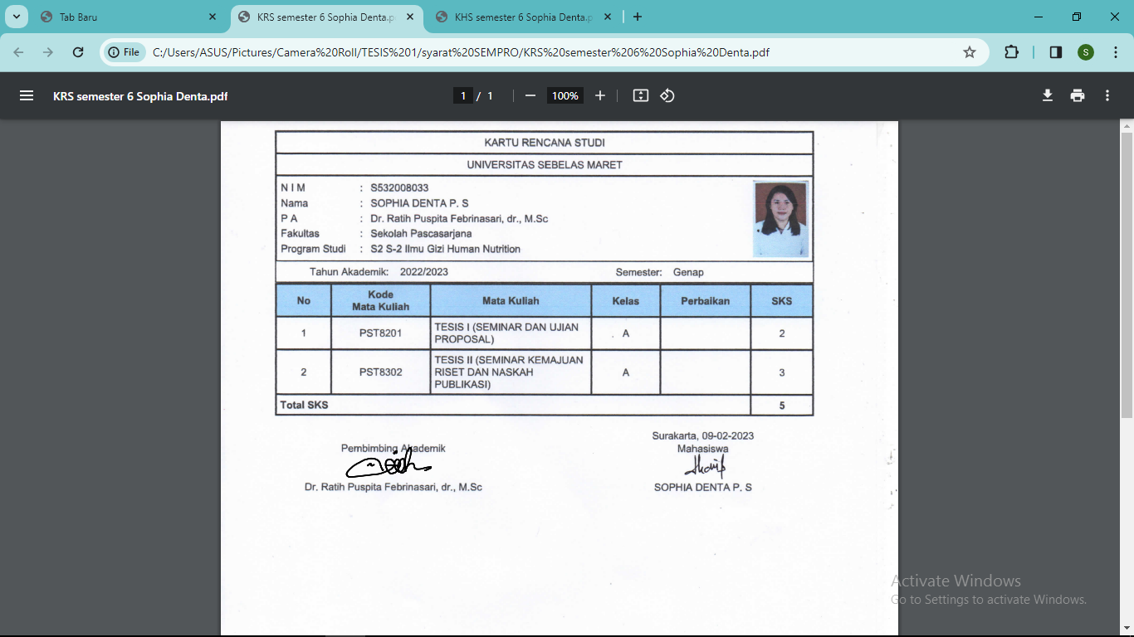 | 11 March 2024
Ida Nurwati | 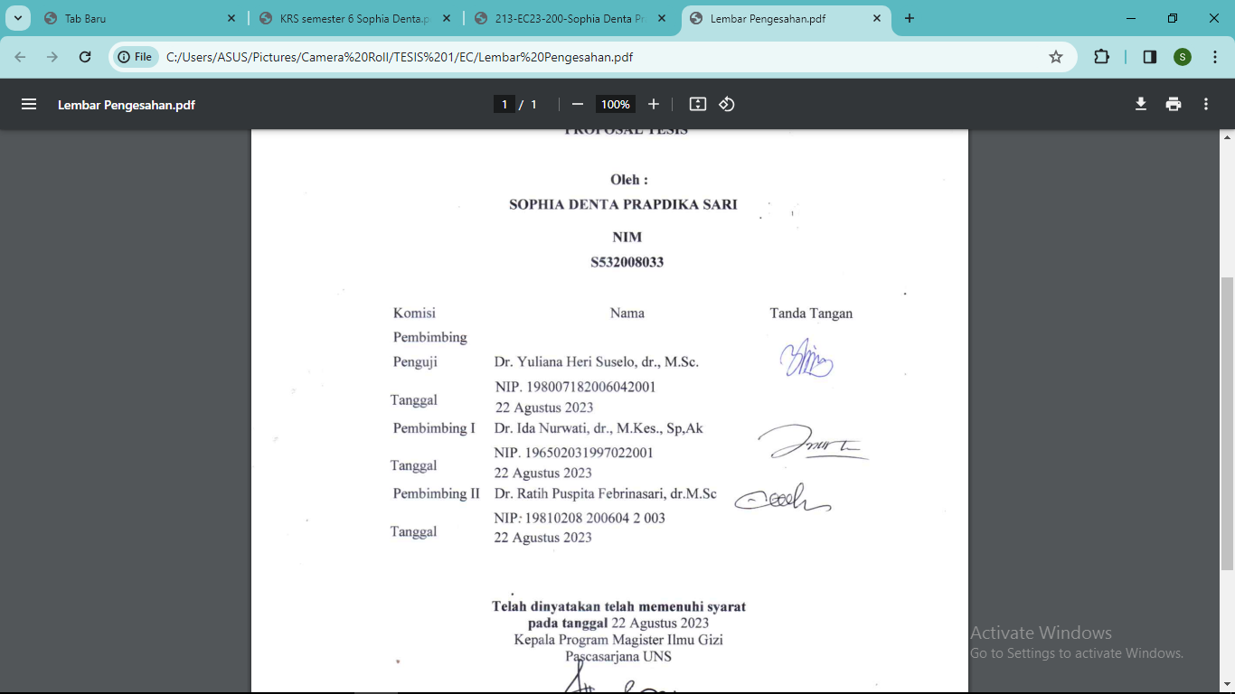 | 11 March 2024
Ratih Puspita Febrinasari |  | 11 March 2024

