LETTER OF APPROVAL OF SCIENTIFIC MANUSCRIPT PUBLICATION
Signed below:
Author:
1. Name : Laila Sholehah email : sholehalail@gmail.com
2. Name : Shanti Listyawati email : shantilistyawati@staff.uns.ac.id
3. Name : Arief Nurudhin email : ariefnurudhin@staff.uns.ac.id

Corresponing author’s name and email address:
Name : Laila Sholehah
Email : Sholehalail@gmail.com

States that the scientific text:
……………………………………………………………………………………………….

The above manuscript has been examined by the advisers and authors, contains no fabrication, falsification, and plagiarism, and has been approved the final form of the manuscript by all authors to be published through our agreement in Jurnal Gizi dan Dietetik Indonesia (Indonesian Journal of Nutrition and Dietetics).
- In order to maintain the quality of this scientific manuscript we are also willing to correspond with the editor in the editing process and give the editor confidence to make changes that are deemed necessary for the publication of this publication.
- The author is also willing to pay a publication fee of IDR 1.500.000,- after it is declared acceptable for publication and before submission of LOA (Letter of Accepted) which can be billed to* :
( ) Main Author
(√) Correspondence Author

Who made the statement:
Author name | Signature | Date
Laila Sholehah | 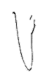 | 6 Juni 2022
Shanti Listyawati | 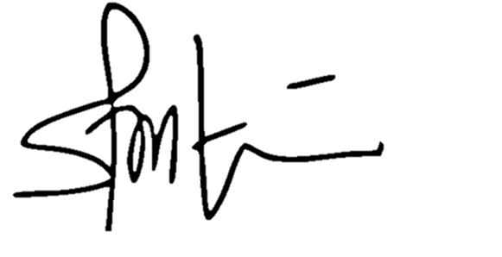 | 6 Juni 2022
Arief Nurudhin | 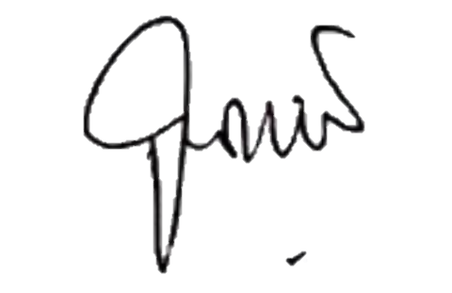 | 6 Juni 2022

