CREATIVE ECONOMY IMPROVEMENT WITH ENTREPRENEURSHIP FOR THE PEOPLE OF SEMARANG CITY

KMT Lasmiatun
Faculty of Economics, Muhammadiyah University Semarang, Indonesia

* Corresponding author: lasmiatunmsi@gmail.com

 | ABSTRACT
Article Info  Article History  Received : November 30th, 2023  Revised : Desember 14th, 2023  Accepted : Januari 23rd, 2024  Article DOI:  10.14421/EkBis.2022.6.1.1555  Copyright © 2024 by the author | In facing business competition, the empowerment of human resources needs to be optimized so that people can be competitive, independent and able to compete with other products on the market in the era of the industrial revolution 4.0. The era of revolution 4.0 is a challenge in itself for MSMEs so that efforts are made to overcome these problems, namely socialization of Entrepreneurship and product innovation, socialization of Digital Marketing, socialization of Digital Payment, and investment counseling. The debriefing process requires the role of Community Service Program so that the goals can be created, namely the welfare of the community and educating businessman in business development in the future. This is expected that businessman will be able to create product improvement steps, and several aspects that need to be considered in running a business so that businessman in the Mangunharjo RW 03 will be more independent and innovative in facing business competition in the era of the industrial revolution 4.0.  Keywords: Strategy, Development, MSME, Independent

INTRODUCTION
Micro, Small and Medium Enterprises (MSMEs) have an important role in the economy in Indonesia. MSMEs have a proportion of 99.99% of the total business actors in Indonesia or 56.54 million units. Micro, Small and Medium Enterprises have been able to prove their existence in the Indonesian economy. When the monetary crisis hit Indonesia in 1998, small and medium scale businesses were relatively able to survive compared to large companies. Because the majority of small-scale businesses are not too dependent on large capital or external loans in foreign currency. Thus, when there are exchange rate fluctuations, large-scale companies which generally always deal in foreign currency are the ones with the greatest potential to experience the impact of a crisis (Sarwono, 2015). Micro, Small and Medium Enterprises (MSMEs) are an important part of the economy of a country or region. Various efforts to develop MSMEs have been carried out, one of which is by generating and increasing the number of new people or entrepreneurs in the MSME sector, so that village communities are given skills with the hope that these skills will become a creative business that will benefit the economy of families and village communities. Likewise, creative businesses can also open up new opportunities and jobs for the community (Wahyudi, 2012).
Apart from this, the development of MSMEs in Indonesia is still hampered by a number of problems, including weak MSMEs in terms of capital and managerial aspects (management capabilities, production, marketing and human resources); as well as problems that arise from developers and MSME coaches, for example the solutions provided are not on target, there is no monitoring or supervision and overlapping programs between institutions and a lack of experience in digital matters or what is usually called industrial revolution 4.0 (Suci, 2008). The development of the digital era is increasingly being felt by society, namely entering the industrial revolution 4.0 and society 5.0 which is demonstrated by all data, human connectivity and digitally connected machines (Nugroho & Andarini, 2020). The advances in information technology currently being faced are rapid changes in the fields of science and technology, and can even create an increasingly open world and create a dependency effect between nations and countries (Hidayat, 2017). The industrial revolution is a fundamental change in human work processes, with advances in information technology that can integrate the digital world of life and have an impact on all scientific disciplines.
The presence of the Industrial Revolution 4.0 era will bring about changes in human work systems in various professional fields. Including the MSME business sector, it will be affected by the industrial revolution 4.0. MSMEs inevitably have to be aware of Information Technology which will change work patterns and mindsets. One of the challenges that must be faced in the industrial era is disruptive innovation which will become a pillar/support in every business activity, where small companies with limited resources must be able and able to survive entering the market and replacing existing systems. In this condition, opportunities, opportunities, challenges and benefits can arise for the sustainability and credibility of a company, including MSMEs, and not also for existing economic growth (Fauziyah, 2020). Economic growth in Indonesia can be influenced by the development of MSMEs. New technology in the industrial era 4.0 is one of the obstacles to the development of MSMEs in Indonesia, because MSME players do not have the ability to adopt new technology. If MSMEs can utilize technology such as sales information systems, social media and Google My Business, then this technology will be able to help in the sales, marketing and communication processes with customers (Berlilana et al., 2020).
The industrial revolution 4.0 can provide opportunities and challenges for MSMEs because it can have the impact of increasing the MSME trade sectors more rapidly. The existence of MSMEs is a small-scale business that can survive the shock of the economic crisis and can contribute to national economic development. The presence of the industrial revolution 4.0 and society 5.0 is expected to provide positive value for MSMEs and enable them to develop independently. The convenience that has been experienced in the era of industrial revolution 4.0 and society 5.0 in digital technology can be utilized by the community in developing MSME activities, especially in Mangunharjo RW 03 Village. Mangunharjo sub-district is a location with an area of ​​303,796 km2 and regional boundaries include Sambiroto (north), Meteseh-Bulusan (south), Tembalang-Jangli (west) and Sendangmulyo (east). The population of Mangunharjo Village is 12,235 thousand people and 3,837 family cards. Group 03 KKN is centered on one point at the RW level, which is carried out in the RW 03 area which is located on Jalan Gendong, Mangunharjo Village, Tembalang District, Semarang City. Mangunharjo sub-district is a sub-district that has the majority of residents working as industrial workers.
There are relatively few MSMEs in RW 03 and the business owners are women who work as private employees and open MSME businesses as a side business with an age range of 29 years to 52 years. Meanwhile, small-scale MSMEs in Mangunharjo Subdistrict, especially in RW 04, are less developed, there are 13 of them from the number of women with an age range of 29 years to 52 years who are in RW 03, namely 466 people with various professions. With optimism regarding the growth of the role of MSMEs, as well as the potential possessed by the Indonesian nation, in this case community service activities are trying to bridge the increase in digital literacy among the MSME community. Optimizing community potential in various aspects, namely in developing business ideas, business licensing and marketing strategies, needs to be studied further with MSME players. It is hoped that the presence of students in the community will be able to provide specialized knowledge in the fields of economics and technology so that the community can improve their ability to run businesses among the MSME community in Mangunharjo RW 03 Subdistrict.

METHOD
This research uses qualitative methods, which combine structured interview methods, in-depth interviews and observations of MSME actors. Theoretically, the qualitative research format is different from the quantitative research format. This difference lies in the difficulty in creating a qualitative research design, because in general qualitative research has no pattern (Rachmawati et al., 2021). According to Bogdan and Taylor (1975) quoted in Moloeng (2007), qualitative methodology is a research procedure that produces descriptive data in the form of written or spoken words from people and observable behavior. Furthermore, Williams (1995) as quoted in Moloeng (2007) argued that qualitative research is collecting data in a natural setting, using natural methods, and carried out by researchers who are naturally interested.
The implementation of this community service program is in the Mangunharjo RW 03 Village area, Tembalang, Semarang City. Participants in activities to improve the creative economy through entrepreneurship are the people of Mangunharjo RW 03 Village in the form of counseling and training, namely Digital Marketing socialization, Digital Payment socialization, socialization about entrepreneurship, and investment counseling. This activity is carried out by being directly involved in the community, so that good communication can be established between students and the community of RW 03, Mangunharjo Village. This socialization program uses various methods, including:
- Lectures are used for regular outreach and counseling activities. Examples of lecture activities are: Digital Marketing outreach, Digital Payment outreach, entrepreneurship outreach, and investment counseling.
- Practice, this method is a method of providing education to the public through practical activities. Examples of practical activities are: marketing training through e-commerce and product innovation.

RESULTS AND DISCUSSION
The initial activity in improving the creative economy through entrepreneurship is a survey (field review) and data collection on MSMEs in Mangunharjo Subdistrict RW 03. Data collection was obtained from RW 03 data as well as data from Mangunharjo Subdistrict. A survey (field review) was also carried out to see the condition of MSMEs already operating in Mangunharjo RW 03 Subdistrict in terms of products, equipment, marketing and business premises. MSME data for RW 03 Mangunharjo Subdistrict is as follows:
Graph 1. MSME’s RW 03 Mangunharjo Subdistrict

The results showed that there were 13 MSMEs in Mangunharjo RW 03 Village with an age range of 29 years to 52 years with the majority of their main profession being private employees. It can be said that the MSME business carried out by women who are entrepreneurs is a side job, not a main job. The majority of MSMEs in Mangunharjo Subdistrict are in the food sector, such as duck egg, fried food, gethuk, grocery stalls and lunpia businesses. Several MSMEs located in Mangunharjo RW 03 Subdistrict are still at a developing stage because they still have a system of making products only when ordered and are not continuous/producing products every day. Meanwhile, compared to potential mothers aged 29 years to 52 years from the Mangunharjo Subdistrict data collection, especially in RW 03, there were 466 people with various professions. It can be concluded that only 2.78% of mothers with an age range of 29 years to 52 years are MSME entrepreneurs. This potential can be followed up because the majority of human resources in Mangunharjo Subdistrict are not many who are interested in working as MSME business actors and it is hoped that this activity can increase enthusiasm and business opportunities for prospective new business actors so that it can increase state income.
In activities to increase the creative economy through entrepreneurship, KKN-PPM participates in increasing insight and developing MSMEs in Mangunharjo Subdistrict, especially in RW 03, namely providing outreach and practices to optimize human resources with various aspects in order to obtain prosperity and productivity for the community. The second activity in improving the creative economy through entrepreneurship is providing education and insight regarding the socialization of MSME businesses and product innovation with the aim of providing knowledge about ideas. A business is created because there is an initial idea that encourages someone to carry out business activities. The business idea can come from pure innovation that comes from a person's personality in creating a product or modification or improvement of a previously existing idea. Developing product creativity in building a business (Nuraharto, 2021).
The generation of a business idea is the first step as well as all concepts, thoughts, knowledge, views, beliefs or plans for business activities. There are 4 types of ideas for starting a business, namely invention (new discovery), extension (development of a previously existing one), duplication (doubling, increasing existing and well-known products) and synthesis (merging or combining existing concepts and formulas into a formula). the new one). Invention is a product innovation carried out because the utilization of natural resources has not been maximized due to a lack of technological innovation. There are several important points, namely product innovation and packaging innovation so that they can attract consumer interest. One example of the use of natural resources in Mangunharjo Village is bamboo shoots which are usually processed into vegetables, are now processed into lunpia. In this activity, business actors pay attention to various steps on how to create ideas that are out of the box so that it is hoped that business actors will be able to implement and pay attention to the initial steps in entrepreneurship.
Figure 1. Design Thinking for Marketing
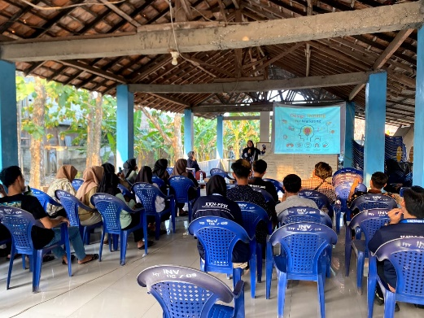
Source: Community Service Activities
The third activity is socialization related to Digital Marketing, namely the socialization of insight into expanding the reach of the MSME market with the aim of increasing the capabilities of various sufficient resources to create products that can satisfy everyone and the products can be marketed to everyone, so market segmentation is designed so that the process of expanding the market is greater. focused, directed and effective. Where expanding the reach of the MSME market is not just reaching the traditional market but adapting to the current revolution, namely reaching the digital market, where the ultimate goal of this reach is to introduce products to all groups of people. In this case, the introduction of marketing media or digital marketing is also needed to achieve the expected market targets according to Gunawan et al., 2022, namely as follows:
- Facebook marketing is marketing activities using Facebook. The goals of Facebook marketing:
- Improving society,
- Establishing relationships between buyers and sellers in a business environment,
- Building credibility to inspire customer trust in Facebook marketing,
- Interaction with customers,
- Take advantage of Facebook's built-in sales tools, especially the ability to create an online store directly on a fan page,
- Drive more potential customers to the business website.
- Marketplacesis a buying and selling platform that you can use as free promotional advice. You don't need any other fees to promote each product you want to market.
- Instagram marketing, used to share photos or videos with online businesses by promoting their products via Instagram.
Marketing training via e-commerce, with the understanding that e-commerce applications are Android-based applications which are generally almost the same as online buying and selling applications. This application can offer many opportunities or opportunities to reach a wider range of consumers (Wahyuni ​​et al., 2021). The use of e-commerce makes it easy for MSME partners to carry out marketing, organize consumer orders and carry out transactions effectively (Sugianto & Utama, 2021). Several business actors implement direct selling of their product orders through outlet sales. It is hoped that this training will aim to expand the MSME market more widely and facilitate product promotion and attract more customers. In the current market development, it requires all MSMEs to turn back the road to marketing products, namely via digital or e-commerce, where in this way, apart from being able to attract more customers as stated above, you can also introduce products in the digital market so that they are better known. all communities with the ultimate goal of increasing profits from MSME businesses.

Figure 2. Digital Marketing Socialization
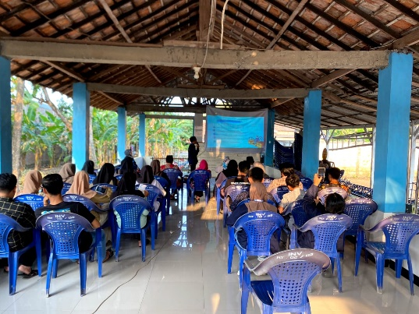
Source: Community Service Activities

The fourth activity is the socialization of Digital Payment or e-payment which aims to increase knowledge about the use and benefits of electronic payments. Digital payments are very useful, especially to support product marketing via e-commerce. Some of the benefits of using digital payments for MSME players are that they provide convenience and security in transactions, certainty in payments, and time efficiency because there is no need to quote prices. Digital payment is a payment method that utilizes digital technology. Simply put, this payment method utilizes the internet network and a number of devices to get the benefits of practicality, efficiency, speed and convenience. Compared to manual methods, digital payments will enable all financial transactions to be carried out in real time. In the past, it took us more than a day to receive money from another bank or when it was sent via money order. With digital payments, we can send and receive money right away as soon as the transaction is completed.
Some of the benefits of digital payments that can be felt are faster payment transactions, ease of payment anywhere and at any time as long as there is internet access and a supporting platform, integration with other financial services so that transactions can be made at any time without worrying about running out of funds, cashless payments that can be made. allows us not to carry large amounts of cash when traveling, practical because with just a gadget and internet access we can carry out various financial transactions, and there is no need to bother looking for an ATM to withdraw money or make transactions.
Figure 3. Digital Payment Socialization
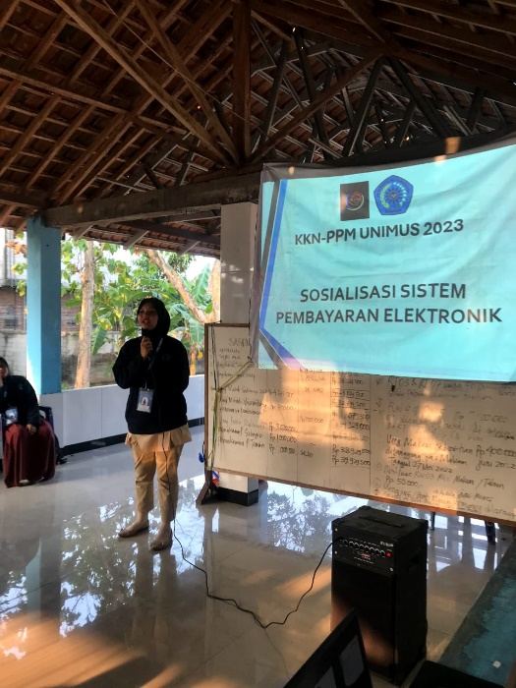
Source: Community Service Activities

The fifth activity is providing information on the importance of investment to youth youth organizations in RW 03, Mangunharjo Village. This activity aims to make local Karang Taruna Youth better understand the importance of investing from an early age which will be beneficial for the future. Investment is an activity of investing capital, either directly or indirectly, with the hope that in the future the owner of the capital will obtain a number of profits from the results of the investment. There are several forms of investment such as shares, deposits, mutual funds, property and gold. The benefits of investing early are, being more mature in planning your finances, being able to prepare emergency funds, getting Passive Income, achieving Financial Freedom. By understanding the importance of investment from an early age, you will be better prepared to prepare for future financial needs in accordance with planned financial goals. To make an investment, we also have to choose products that suit what you need and also have to consider what risks may occur.

Figure 4. Counseling on the Importance of Investing from an Early Age
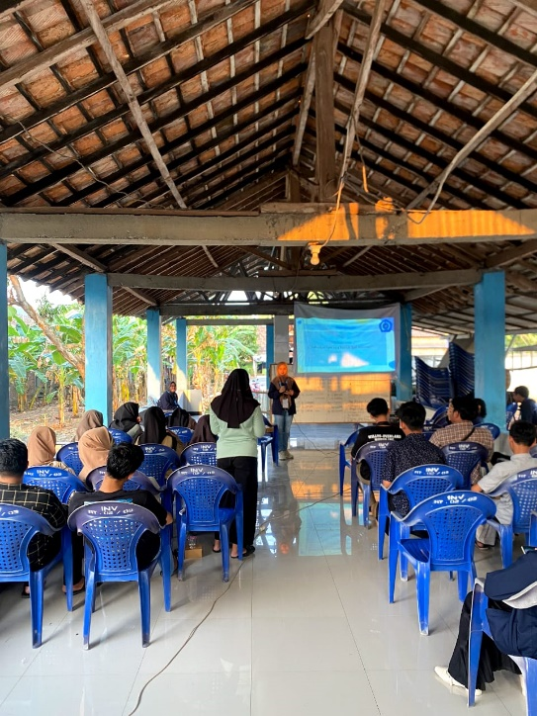
Source: Community Service Activities
CONCLUSION
In facing business competition, human resource empowerment needs to be optimized so that people can be competitive, independent and able to compete with other products on the market in the era of industrial revolution 4.0. The era of revolution 4.0 is a challenge in itself for MSMEs, so the efforts made to overcome these problems are socialization about entrepreneurship and product innovation, digital marketing socialization, digital payment socialization, and investment counseling. The training process requires the role of KKN students so that the goal can be created, namely to improve the welfare of society and educate business actors in business development in the future. It is hoped that business actors will be able to create product improvement steps, and several aspects that need to be considered in running a business so that business actors in Mangunharjo RW 03 Subdistrict will be more independent and innovative in facing business competition in the era of the industrial revolution 4.0.

REFERENCES
Ahmad, M. (2013). Customer Relationship Management Analysis.http://repository.ung.ac.id/%0Aget/simlit_res/1/285/analysis-manajemenkomunikasi-pelanggan.html.
Atia, T. (2021). 5 Tips for MSME Businesses to Continue to Exist and Last Long.www.oyindonesia.com.https://www.oyindonesia.com/blog/tips-usaha-umkm-tetap-eksis-dan-berlahan-lama
Baskara, I. (2022). Business Profile of Micro, Small and Medium Enterprises (MSMEs). Bank Indonesia and LPPI, 08(4), 1-135.
Berlilana, Utami, R., & Baihaqi, WM (2020). The Influence of Industrial Revolution 4.0 Information Technology on the Development of MSMEs in the Matrix Processing Industry Sector, 10.https://doi.org/http://dx.doi.org/10.31940/matrix.v10i3.1930
Fauziyah. (2020). Challenges for MSMEs in Facing the Industrial Revolution 4.0 Viewed from Marketing and Accounting Aspects. 5(38), 155-172.https://media.neliti.com/media/publications/323250-tantangan-umkm-dalam-menghadapi-revolution-d73f236f.pdf
Gunawan, J., Salsabila, AT, Nisa, K., & Azizah, N. (2022). Socialization of the Use of Digital Marketing for MSMEs in Tegalsari Village. Journal of Education and Community Service, 5(2), 146-150.https://doi.org/10.29303/jppm.v5i2.3543
Lasmiatun.(2023). Manajemen Dan Analisis Data. Padang: Global Eksekutif Teknologi.
Lasmiatun.(2023). Research method: kualitatif vs kuantitatif. Sumatra Barat: Penerbit Mitra cendekia pustaka.
Nugroho, RH, & Andarini, S. (2020). The strategy for empowering MSMEs in rural areas is based on local wisdom in the industrial era 4.0 towards the era of society 5.0. Indonesian Business Journal, 93-109. Retrieved fromhttps://core.ac.uk./download/pdf/287192975.pdf
Rachmawati, D., Ramadhani, N., Komarullah, TA, & Purnama, A (2021). Socialization of the role of digital marketing for MSMEs in Ujung Genteng Village. 4 (November).
Sarwono, HA (2015). Business Profile of Micro, Small and Medium Enterprises (MSMEs).https://www.bi.go.id/id/umkm/penelitian/Documents/ProfilBisnisUMKM.pdf
Suci, YR (2008). Development of MSMEs (Micro, Small and Medium Enterprises) in Indonesia. upp.ac.id, 6(1), 1-31.
Sugianto, N., & Utama, FP (2021). E-Commerce to Optimize Product Marketing in the Digital Era for Micro Enterprises of the Pangestu People's Farmer Group, Barumanis Village, Rejang Lebong Regency. Journal of Community Service, 27(1), 14.https://doi.org/10.24114/jpkm.v27i1.23656

